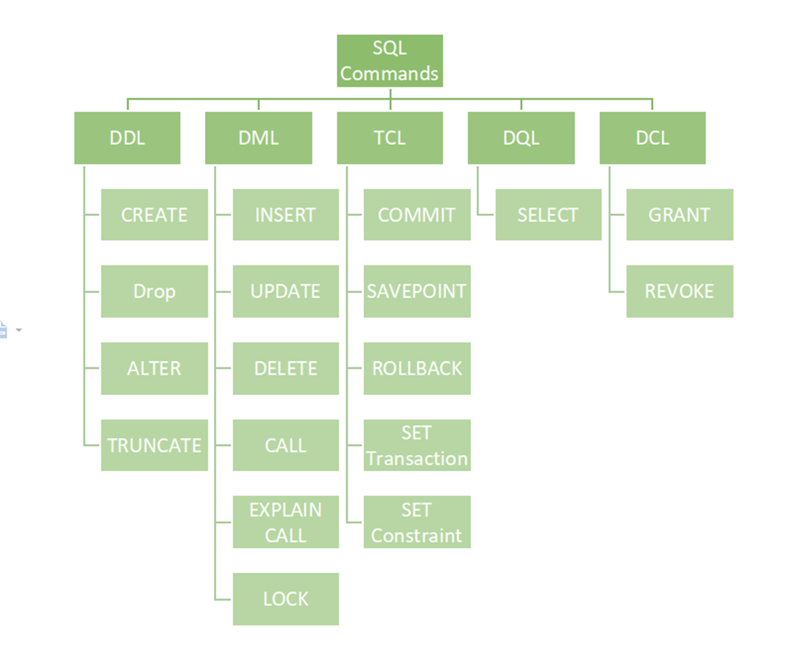

**DCL- Data Control Language**

* Rights,Permissions and other control of database system
* Securing database

|  |  |
| --- | --- |
| GRANT  Give user access privileges to the db  Privilege -to execute particular query or to access another user’s object  *SYSTEM privileges  Perform particular action or on any schema type  User with system privilege  User with ADMIN OPTION  *OBJECT PRIVILEGES  Right to perform a particular action on a specific schema object(table,view,sequence,procedure,function,package) |  |
| CREATE ANY TABLE  GRANT privilege_name | role TO {user_name|PUBLIC|role_name}  [WITH ADMIN OPTION]  Privilege_name🡪ALTER TABLE,DROP USER  Ex.  GRANT create trigger TO user1 WITH ADMIN OPTION |
| GRANT privilege_name  ON object_name  TO {user_name|PUBLIC|role_name}  [WITH GRANT OPTION];  Ex.  GRANT SELECT ON user1.employees  TO user2 WITH GRANT OPTION; |
| REVOKE  Withdraw access privileges  **CASCADING REVOKE-> happens in Object privileges only** | **Revoke object privileges**  REVOKE privilege_name  ON object_name  FROM {user_name|PUBLIC|role_name}  **Revoke system privileges**  REVOKE privilege_name  FROM {user_name|PUBLIC|role_name}  EX.  REVOKE Create any table,Create any view  From user2; |

**TO get all grantee and grantor info**

SELECT * from user_tab_privs;

**ROLE 🡪** set or group of privileges that can be granted to user or another role

Role initially empty ,can add or remove privileges

CREATE ROLE role_name

[NOT IDENTIFIED] No password is require to enable the role

IDENTIFIED {BY password | USING [schema.]package | EXTERNALLY | GLOBALLY }] ;

| | |

Must supply pass user must authorize authorize by enterprise

by external service directory service

like os or third party service

**TCL-TRANSACTION CONTROL LANGUAGE**

Deals with transaction within the DB

* After commit all savepoints are erased,previous state lost

|  |  |
| --- | --- |
| COMMIT  Commits transaction | COMMIT; |
| ROLLBACK  Rollback a transaction | ROLLBACK to savepointName; |
| SAVEPOINT  Set a savepoint within the transaction | SAVEPOINT nameToSavepoint; |
| SET TRANSACTION  Specify characteristics for the transaction |  |

Functions in sql (string index start with 1)

|  |  |
| --- | --- |
| Concatenation of string | CONCAT(string1,string2)  3 string to cancat  CONCAT(CONCAT(string1,strin2),string3) |
| REPLACE  Replaces all occurrences of a substring within a string, with a new substring | REPLACE(string,old_string,newstring) |
| SUBSTRING  Extracts some characters from a string | SUBSTR(string,start,length) |
| LEN  Return length of string | LENGTH(string) |
| RTRIM  Removes trailing spaces from a string  LSTRIM | RTRIM(string) |
| LOWER | LOWER(string)  UPPER(string) |
| reverse | REVERSE(string) |
| LPAD  These functions return the strings padded to the left or right ( as per the use ) | LPAD(column|expression,n,’string’) |

**JOIN**

|  |  |
| --- | --- |
| INNER JOIN | Select  From table1  INNER JOIN table 2  ON condition  Where ---; |
| Cross join | Select  From table1  CROSS JOIN table2  Where condition_any; |
|  |  |
|  |  |
|  |  |
|  |  |
|  |  |
|  |  |

|  |  |
| --- | --- |
| Insert multiple values at once | insert into al_role values(1,'Student'),(2,'Alumni'); |
| Changing the value of some recors | UPDATE table_name  SET COULMN_name=value  WHERE condition if any |
|  |  |
|  |  |
|  |  |
|  |  |
|  |  |
|  |  |

|  |  |
| --- | --- |
| **ALTERING STRUCTURE OF TABLE** |  |
| Renaming a column name | ALTER TABLE building  RENAME COLUMN email_address TO email; |
| To add new column with type and contraints | ALTER table building  ADD description VARCHAR(255) NOT NULL; |
| Deleting a column | ALTER table building  DROP COLUMN address; |
| to change datatype of column | ALTER TABLE building  MODIFY owner_name varchar(500); |
| Rename table name | ALTER TABLE old_table_name  RENAME TO new_table_name |
|  |  |
| CREATE TABLE with name to primary key | CREATE TABLE Persons (  ID int NOT NULL,  LastName varchar(255) NOT NULL,  FirstName varchar(255),  Age int,  CONSTRAINT PK_Person PRIMARY KEY (ID,LastName)  ); |
|  |  |
|  |  |

|  |  |
| --- | --- |
| For XML AUTO |  |
| Declare | To declare a variable |
|  |  |
|  |  |
|  |  |
|  |  |
|  |  |
|  |  |